Easy rental

A PROJECT REPORT

BY

TEAM NO. 124

DHARMENDRA SANKHLA (E9CSE353)

VAIBHAV SETHIA (E19CSE321)

SUBMITTED TO

DEPARTMENT OF COMPUTER SCIENCE ENGINEERING BENNETT UNIVERSITY

GREATER NOIDA, 201310, UTTAR PRADESH, INDIA

NOVEMBER 2020

# DECLARATION

We hereby declare that the work which is being presented in the report entitled “Easy Rental”, is an authentic record of our work carried out during the period from August 2020 to November 2020 at the Department of Computer Science and Engineering, Bennett University Greater Noida.

The matters and the results presented in this report has not been submitted by us for the award of any other degree elsewhere.



Signature of Candidate

Dharmendra Sankhla

(Enroll. No. E19CSE353)



Signature of Candidate

Vaibhav Sethia

(Enroll. No. E19CSE321)

# ACKNOWLEDGEMENT

We would like to take this opportunity to express my/our deepest gratitude to our mentor, **Dr. Tapas Badal (Assistant Professor)** for guiding, supporting, and helping us in every possible way. We were extremely fortunate to have him as our mentor as he provided insightful solutions to problems faced by us thus contributing immensely towards the completion of this capstone project. We would also like to express our deepest gratitude to VC, DEAN, HOD, faculty members, and friends who helped us in the successful completion of this capstone project.



Signature of Candidate

Dharmendra Sankhla

(Enroll. No. E19CSE353)



Signature of Candidate

Vaibhav Sethia

(Enroll. No. E19CSE321)

TABLE OF CONTENTS

ACKNOWLEDGEMENTS iii

TABLE OF CONTENTS…………………………………………………………………………iv

LIST OF TABLES vi

LIST OF FIGURES viiii

LIST OF ABBREVIATIONS viii

ABSTRACT ix

1. INTRODUCTION 1

1.1. Problem Statement 1

2. Background Research 2

2.1. Proposed System 3

2.2. Goals and Objectives 3

3. Project Planning 4

3.1. Project Lifecycle 4

3.2. Project Setup 5

3.3. Stakeholders 6

3.4. Project Resources 6

4. Project Tracking 7

4.1. Tracking 7

4.2. Communication Plan 7

4.3. Deliverables 8

5. SYSTEM ANALYSIS AND DESIGN 9

5.1. Overall Description 9

5.2. Users and Roles 9

5.2.1. Activity Diagram 10

5.2.2. User Case Diagram 11

6. User Interface 12

6.1. UI Description 12

6.2. UI Mockup 12

7. Algorithms/Pseudo Code 15

8. Project Closure 16

8.1. Goals / Vision 16

8.2. Delivered Solution 16

8.3. Remaining Work 16

REFERENCES 17

LIST OF TABLES

Table Page

Table 1: Setup 5

Table 2: Stakeholders 6

Table 3: Resources 6

Table 4: Tracking 7

Table 5: Regularly Scheduled Meeting 7

Table 6: Deliverables 8

Table 7:Team Members and Roles 9

LIST OF FIGURES

Figure Page

Figure 1:Activity Diagram 10

Figure 2:User Case Diagram 11

Figure 3: UI Homepage 12

Figure 4: UI Listings 13

Figure 5: UI Reservation 13

Figure 6: UI Room 14

Figure 7: UI Conversation 14

Figure 8: Production Code 15

Figure 9: Production Code 15

LIST OF ABBREVIATIONS

Abbreviation Explanation of the Abbreviation

N.S.S. O National Sample Survey Office

FCCI Federation of Indian Chambers of Commerce & Industry

VCS Version Control System

ABSTRACT

An estimated 71 Mn or almost 26 % of children in India attend private coaching classes, according to the N.S.S.O1 report and 40 Mn of employees had to move to another state in pursuit of a job. These people have to look out for an affordable home on rent. Students, to get a better education in coaching or higher education have to leave home and look out for PG near the institutions. For an employee, a new job can mean relocating to a different area if the commuting from the current home to the office is completely unfeasible.

Easy Rental is a platform for renting and co-housing. It connects hosts and tenants along with keeping brokers out of the equation. On one side it provides hosts to earn some money by listing their vacant spaces. On the other side, tenants are provided with affordable housing.

Some start-ups like Bengaluru-based No Broker also provide home rent services without any brokerage, but 70% of their revenue comes from subscription plans which are quite high and are often not required once the accommodation has been provided. Easy Rental doesn’t have a subscription model where the users have to pay for 3 months to get all the benefits of the property listing. Our application shows all the listings, from which the user can decide any of them with the help of room reviews, ratings on various parameters. One can also add a rental to his/her wish list for future reference. Once a booking has been made, the user can converse with the host for further agreements.

1. INTRODUCTION

* In India, the majority of youth are either engaged in the employment or education sector. And most have to relocate to a location near to their office or the educational institute. While relocating they do not have the information regarding the affordable rooms near the location and end up living in a high-cost house.
* Easy Rental is a home renting application that provides strategically located, good quality, managed co-housing for students and working professionals. It allows hosts to list their property, students, and working professionals to search properties according to location.
* Further, they will be able to book property. Apart from providing accommodation, Easy Rental allows conveniently ordering delicious home-style food. Thus, Easy Rental is a small step in the way of bringing ‘Ease of Living’ in the life of people.
  1. Problem Statement

Easy Rental is an attempt to solve the following issues:

* Unfair denial of bachelors- Students and working professionals often find it difficult to get long term accommodations at affordable rates. Landlords refuse to rent out to bachelors fearing they would get involved in illegal activities.
* Living alone with no cooking skills- Due to a heavy load of work from office or coaching classes, bachelors are left with no time to satisfy their hunger with nutritional food and had to rely on fast-food chains.
* Dealing with brokers- It stands for everyone looking to rent and wants to cut the broker out of the equation. Easy Rent lets one rent a house without paying any

brokerage and then putting them in touch with potential tenants.

1. Background Research

Research has always been a key fundamental in guiding a project to success. Before starting our project, we have thoroughly researched articles, documents, and similar existing solutions.

1. There have been several articles and surveys which prove that it is better to eliminate the broker from the equation while hunting for a room. An article published by Your Room talks about the same. It says these brokers demand 15-20% of 3 month’s rent as their commission. Sometimes, in the pursuit of renting not so famous property, they even neglect the needs of the tenant.

2. In a recent statement from OYO executive, Rohit Kapoor said that the real estate market in India is expected to cross $1 trillion by 2030. India’s housing market has received investments worth $30 billion from 2008 – 2020.

3. Research conducted by Crunchbase states that in the coming years more than 45% of the Indian population will live in metropolitan cities and urban areas. An average of 0.8 million houses is required every year to meet the demand of the top 5 cities comprising Mumbai, Bengaluru, Delhi, Pune, Noida. One of the reasons for the rising demands of homes is that the students enrolled in coaching institutes or pursuing higher education look for affordable rental accommodation in urban education hubs where they migrate for UG, PG courses.

4. A report by FCCI2 predicts the housing market to increase at a whopping rate of 17% by 2023. National capital leading with a 40% expected growth rate by 2023 and Bengaluru following with 30%.

5. Current market players like Smart Live In and Housing.com have a model of charging a commission. Former charges approximately 12.5% on every booking while the latter charges a hefty16%.

6. Start-ups like No Broker though remove the broker out of the equation but their subscription plans are quite high. As a result, 70% of the revenue of No Broker comes from subscription plans.

7. The home-style food model as proposed by 125 years old Mumbai’s Dabbawalla’s is a perfect example which solves the daily food need of working professionals.

* 1. Proposed System
* Easy Rental has been very meticulously designed to focus on user demands. Our application shows all the listings, from which the user can decide any of them with the help of room reviews, ratings on various parameters.
* Searching for houses is very smooth. Owners can list their property provide the description, rent, feature tags, and images. One can also add a rental to his/her wish list for future reference.
* The tenant can pick the dates from the calendar according to his/her suitability. The owner has an option to accept/decline booking. Once a booking has been made, the user can converse with the host for further agreements.
  1. Goals and Objectives

We want the following features to be the highlight of our project and the customer should enjoy his booking experience:

1. Searching houses and make a valid booking should be smooth, as the booking is the core feature of our application.
2. Owners could list their property provide the description, rent, feature tags, and images. They could provide the location and manage all the rentals. All this is required as owners would be able to completely describe their property.
3. Updating the property information such as location, services, photos, changing tags and description should be possible for tenants to make the right choices.
4. The owner should have an option to accept/decline booking. This eliminates the need for a broker.
5. Project Planning

This section covers the details of the project planning that was agreed upon and followed throughout the semester while developing the website.

* 1. Project Lifecycle
* Basic concepts of React- callbacks, arrow functions, promises, state, props, and life cycle functions.
* Node.js (Server Creation)- Using Express, Postman, MongoDB for data storage.
* Booking rentals- Date range picker in Calendar, building user, and controller models.
* Manage section- Booking layout, create and manage rental sections, user profile section.
* Updating the Rentals section- Editable components by reusability and inheritance.
* Image upload using Amazon S-3- Send an image in a request, crop, and upload image feature.
* Deployment- Platform-Heroku, production server setup.

We have also followed a weekly plan throughout the semester, to maximize our productivity and focus on the project implementation:

* (5th-10st Aug)- Team Forming and Idea brainstorming.
* (10th-20th Aug)- Completing the 1st milestone Form.
* (21st-31st Aug)- Promises and Call back functions, Arrow functions, Postman initialization, create user model.
* (1st-6th Sept)- Create a controller model, Routing, and Validating booking and controller implementation.
* (7th-13th Sept)- Disable booking, Owner section navigation tab, and Geolocation rental area.
* (14th-20th Sept)- Buffer Time.
* (21st-30th Sept)- Rental list manipulate state, New owner section and log in, Logout user and Register form validation.
* (1st-7th Oct)- Create booking, Calendar-date range picker, learn components, services, passing data, links, observable.
* (8th-15th Oct)- Buffer Time.
* (16th-23rd Oct)- Manage booking cards, display booking confirmation, and delete rental features.
* (24th-31st Oct)- Create payment requests such as accept/ decline and Search city requests.
* (1st-6th Nov)- Buffer Time.
* (7th-14th Nov)- Image upload service using Amazon S-3, creating editable components such as image, tags, and UI improvements.
* (15th-20th Nov)- Heroku deployment and testing.

Buffer Time — Includes finishing tasks and handling errors, pushing code to GitHub.

* 1. Project Setup
* **Create Virtual Environment**

In the root directory run the command *pipenv shell* to activate the virtual environment.

* **Run the localhost server**

After creating the virtual environment run *python manage.py runserver* to run the localhost server.

* **Go the website**

<http://127.0.0.1:8000/>

Table 1: Setup

|  |  |
| --- | --- |
| **#** | **Decision Description** |
| 1 | Compatible on all operating system Windows 8, Mac, and Linux |
| 2 | All the coding standards have been followed such as underscore between words used in variables. |
| 3 | Only the project team members have the privilege to merge PRs on GitHub |
| 4 | Pip Environment, Django version 2.2.5, Gulp, and NPM have been used |

* 1. Stakeholders

Easy Rental is a fruitful outcome of not only the team members but also of all those who took their time to provide feedback, suggestions, and monitored our progress throughout the semester.

Table 2: Stakeholders

|  |  |
| --- | --- |
| **Stakeholder** | **Role** |
| Dr. Tapas Badal | Mentor |
| Mr. Deepak Baid | Contributed to suggestion meetings |
| Ashish Binu | Tested our application |
| Dharmendra Sankhla | Team member |
| Vaibhav Sethia | Team member |

* 1. Project Resources

The following are the resources being used while developing Easy Rental.

Table 3: Resources

|  |  |  |
| --- | --- | --- |
| **Resource** | **Resource Description** | **Quantity** |
| SQLite Database | A database server was used with the Django application. | 2 |
| Capstone Team | Our team of students will be the primary developers of the project. | 2 |
| GitHub | VCS3 for maintaining code repositories | 1 |
| MS Visual Studio Code | Code editor for installing the libraries, running server, and coding | 2 |
| WSL  Workstation | A WSL workstation for using Linux command on Windows OS | 2 |
| Python Language | Python 3.6.9 | 2 |

1. Project Tracking
   1. Tracking

The source code was stored and updated timely with regular commits. GitHub was used for version control of the source code. A public repository namely Easy Rental was created along with a local repository on the laptop. The code commits were first pushed in the local repository and once finalized; they were pushed to the master branch.

Table 4: Tracking

|  |  |  |
| --- | --- | --- |
| **Information** | **Description** | **Link** |
| Code Storage | The project code is stored in the GitHub repository. | [Link](https://github.com/VaibhavSethia07/Easy-Rental) |
| Project Documents and Assignments | Milestone progress reports, PPT, poster, activity diagram, and design documents, etc. will be stored in our GitHub repository. | [Link](https://github.com/VaibhavSethia07/Easy-Rental) |

* 1. Communication Plan

During the project development, several rounds of meetings, suggestions, and feedback talks have taken place.

Table 5: Regularly Scheduled Meetings

|  |  |  |
| --- | --- | --- |
| Meeting Type | Frequency/Schedule | Who Attends |
| Team Meeting | Weekly | The project team and mentor |
| Team Meeting | Weekly | Project team |
| Short Meeting | Monthly in class | Project team |
| Feedback | Start of project | The project team and potential users |
| Suggestions | Monthly | Industry member |

* 1. Deliverables

Following are the major deliverables that our semester project showcases:

Table 6: Deliverables

|  |  |  |
| --- | --- | --- |
| **#** | **Deliverable** |  |
| 1 | Code | [Link](https://github.com/VaibhavSethia07/Easy-Rental) |
| 2 | Build & Install process documents | [Link](https://github.com/VaibhavSethia07/Easy-Rental) |
| 3 | Final report, PowerPoint presentation | [Link](https://github.com/VaibhavSethia07/Easy-Rental) |
| 4 | YouTube video | [Link](https://youtu.be/Yn7LIHJjZQc) |
| 5 | Medium blog | [Link](https://dark-war-s.medium.com/easy-rental-34e870229c9e) |
| 6 | Twitter post | [Link](https://twitter.com/dark_war_s?s=08) |

1. SYSTEM ANALYSIS AND DESIGN
   1. Overall Description

Easy Rental application has the backend divided into real and all third-party services to minimize their crashing. Some of the essential services are:

* Searching and filtering
* Room booking
* Cache synchronization services
* Payment services
* Messaging & reviewing

1. All the information related to booking is stored in the PostgreSQL database. The fluctuations in the database server mean that a user who booked the property won’t be able to see the booking status.
2. More users will use “search” than making a booking. We have made search efficient, ensuring that the failure of the search doesn’t take down booking functionality.
3. In-application calendar- These services will make it easy for the user to decide the date.
   1. Users and Roles

We are a team of 2 members and have distributed the work equally between us.

Table 7: Team Members and Roles

|  |  |
| --- | --- |
| **User** | **Description** |
| Dharmendra Sankhla | Worked on booking controller, owner section navigation, rental list manipulate state, login, register form validation, logout user, calendar-date range picker, display booking confirmation in modal, search city request, rental layouts, editable components- image and tags. |
| Vaibhav Sethia | Implemented user model and controller, routing and validating booking, show rental owner, creating booking and handle edge cases, new owner section, and manage booking cards and UI improvements. |

* 1. Design diagrams/ UML diagrams/ Flow Charts/ E-R diagrams
     1. Activity Diagram

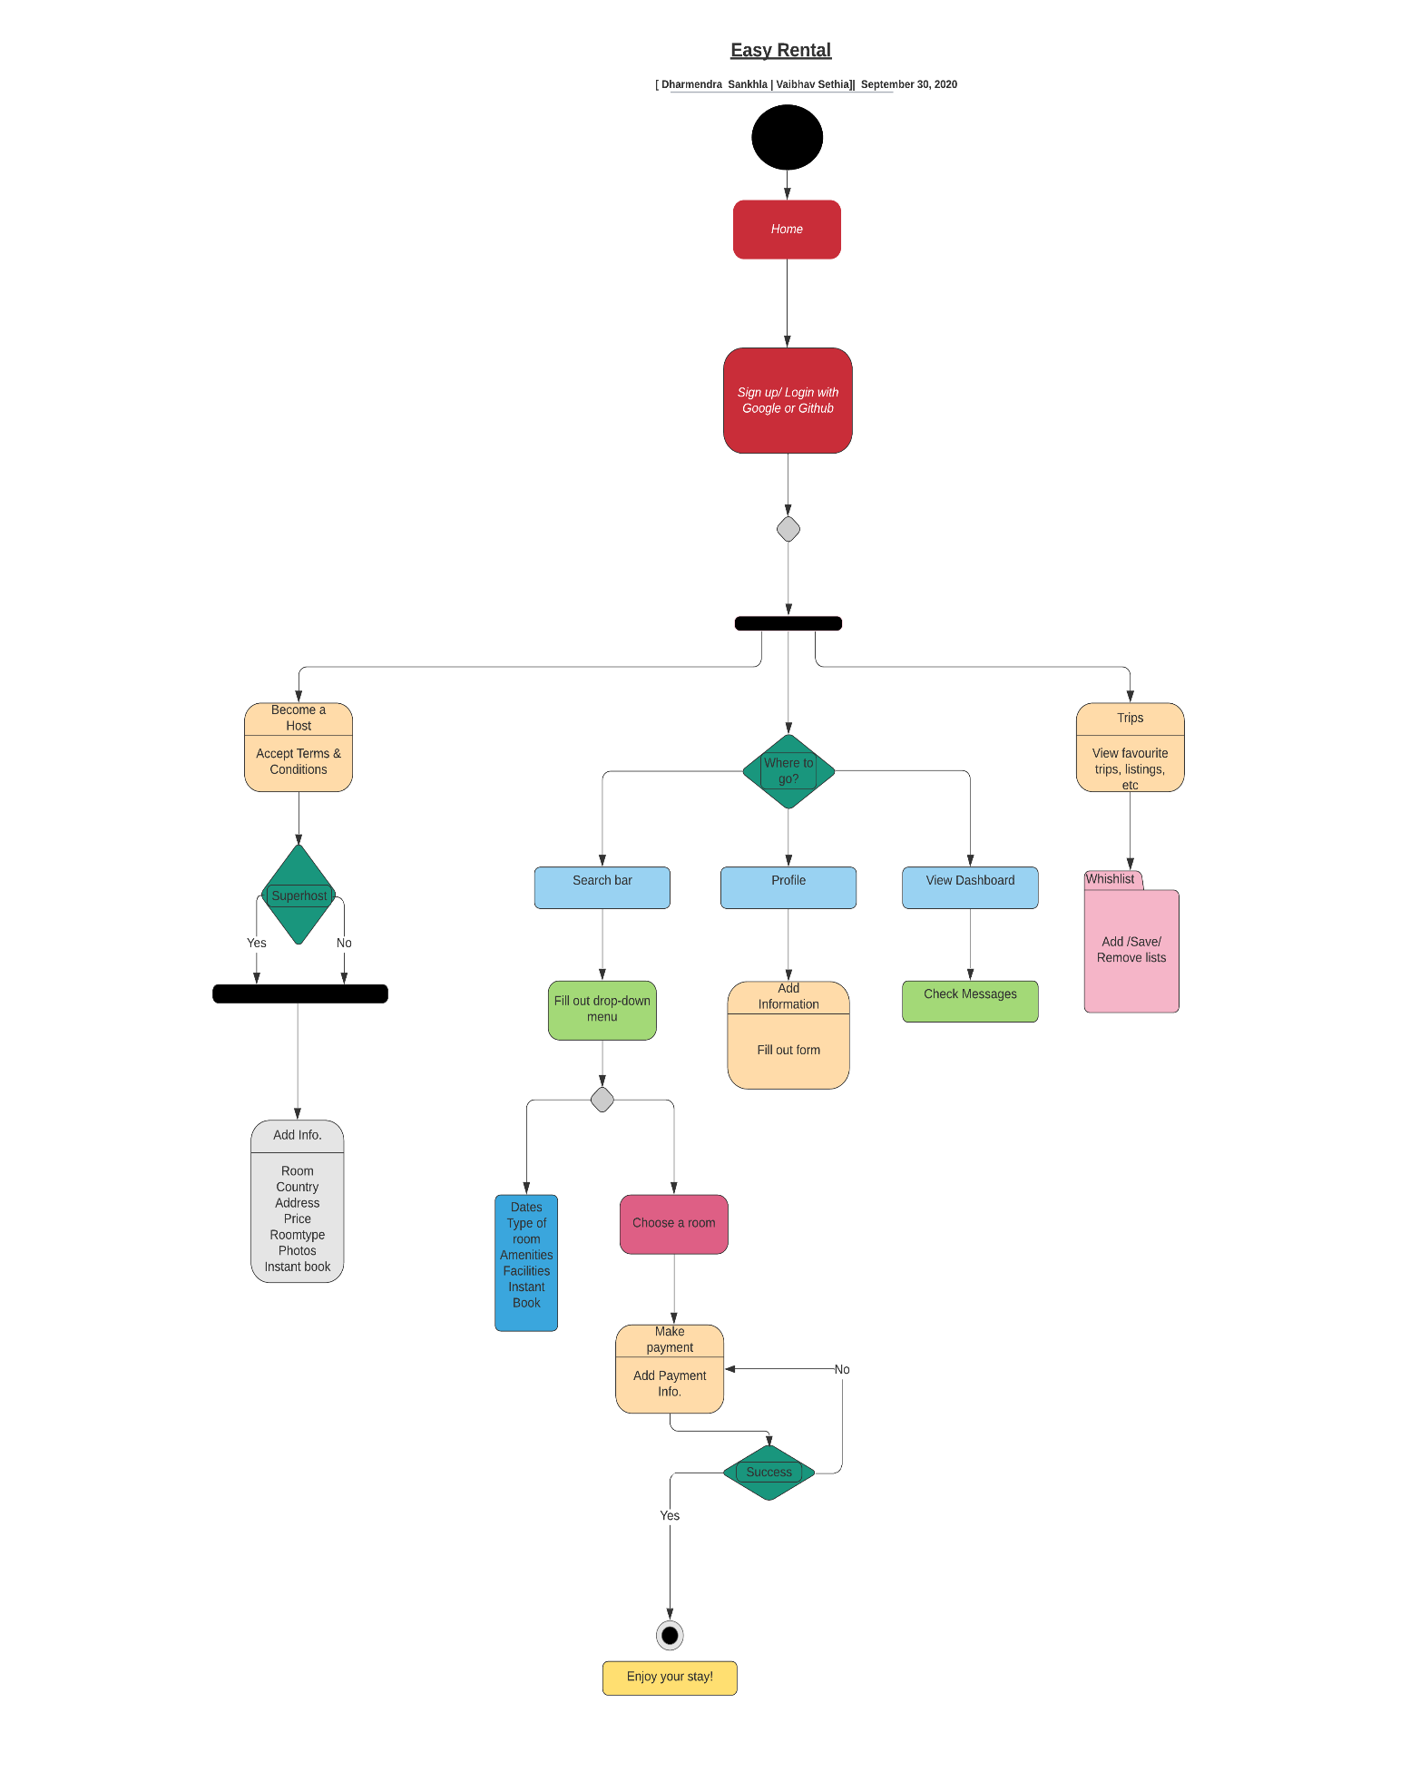

* + 1. User Case Diagram

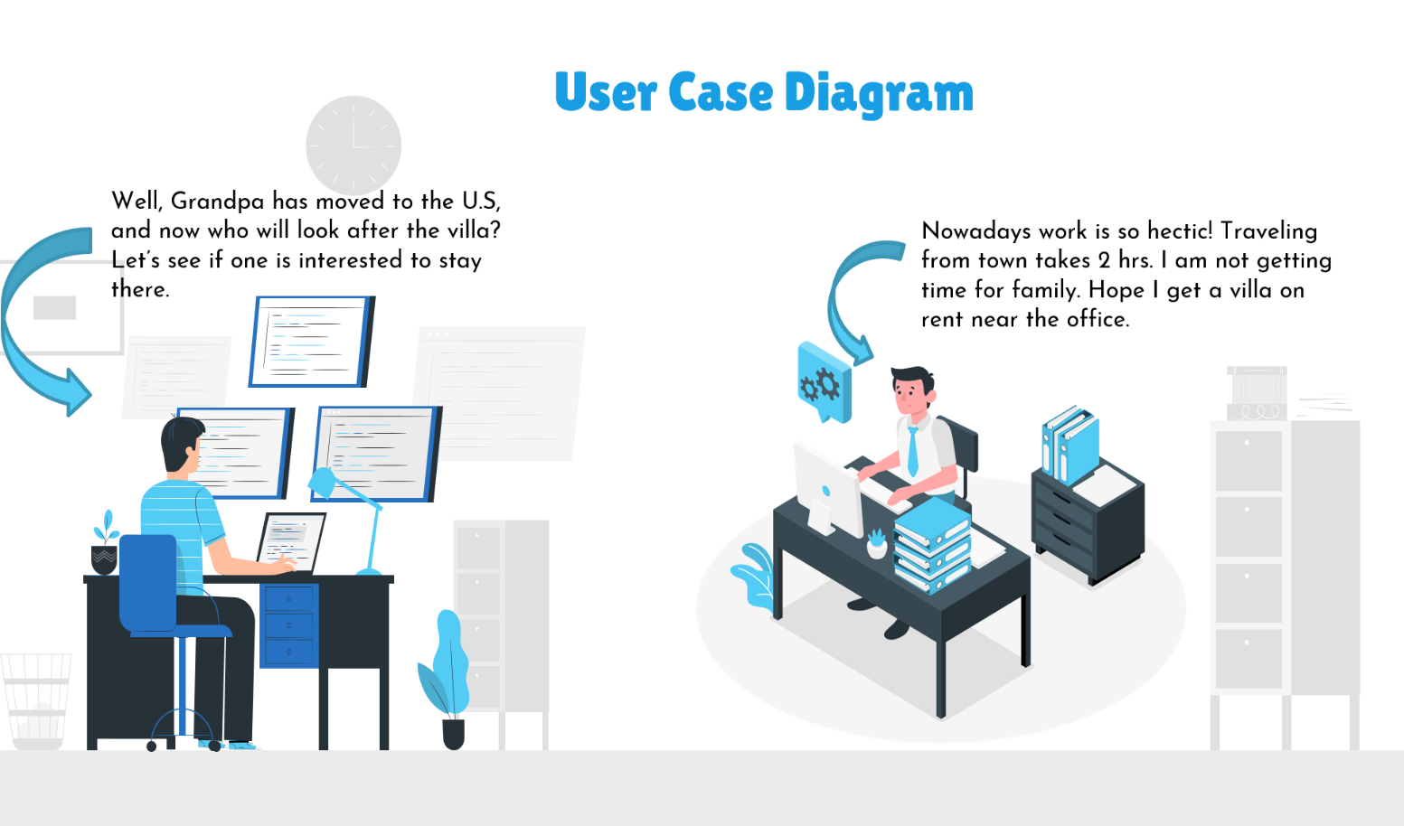

1. User Interface
   1. UI Description

We have focused to keep the user at the center of product design and development to earn their trust and thereby increase the userbase.

1. Visibility- Users would be able to see what kind of room, location, and price is suitable to them using photos, Google maps, and filters.
2. Accessibility- Customers would have a variety of options to get information quickly using the search bar, amenities, and facilities filters. Even a tenant can make a wish-list of all places he would like to stay.
3. Paperwork assistance- In case of any query the customer can email the Easy Rental team on an email-id mentioned on the website. This will ensure a hassle-free query process.
   1. UI Mockup

Figure 2: 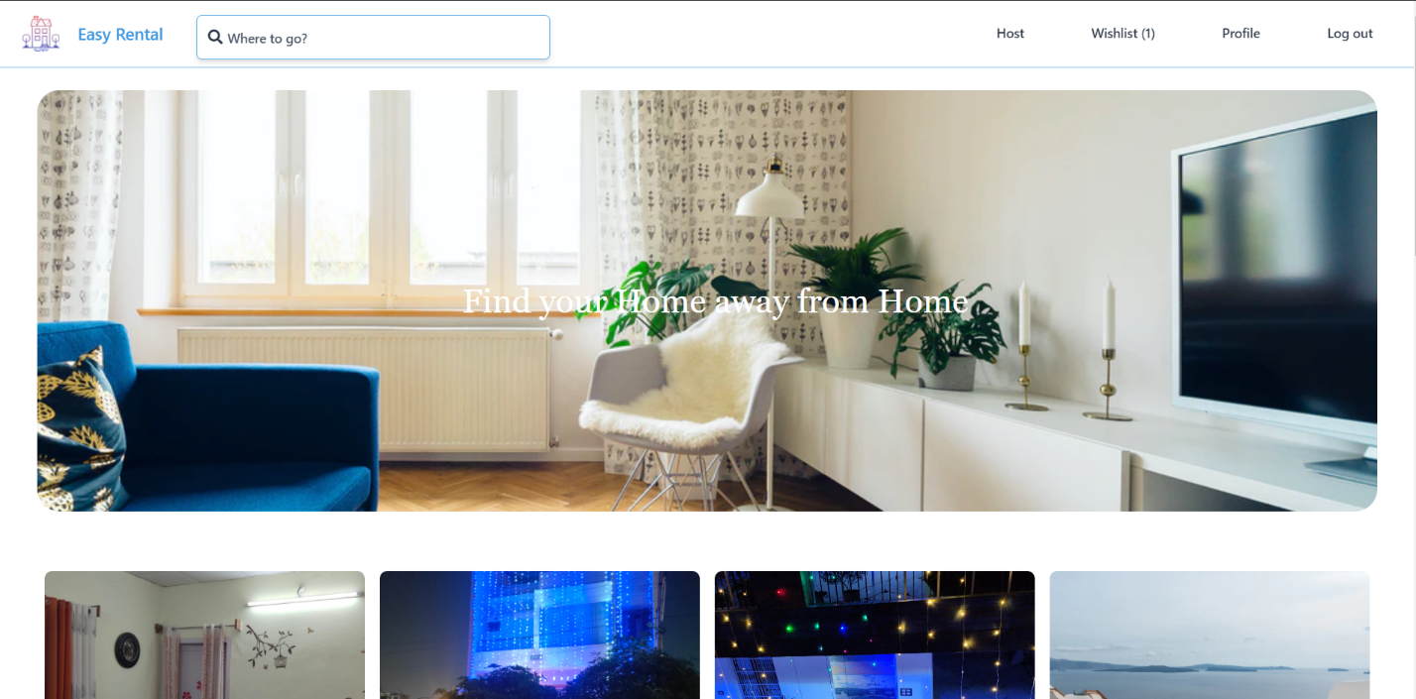 Figure 3: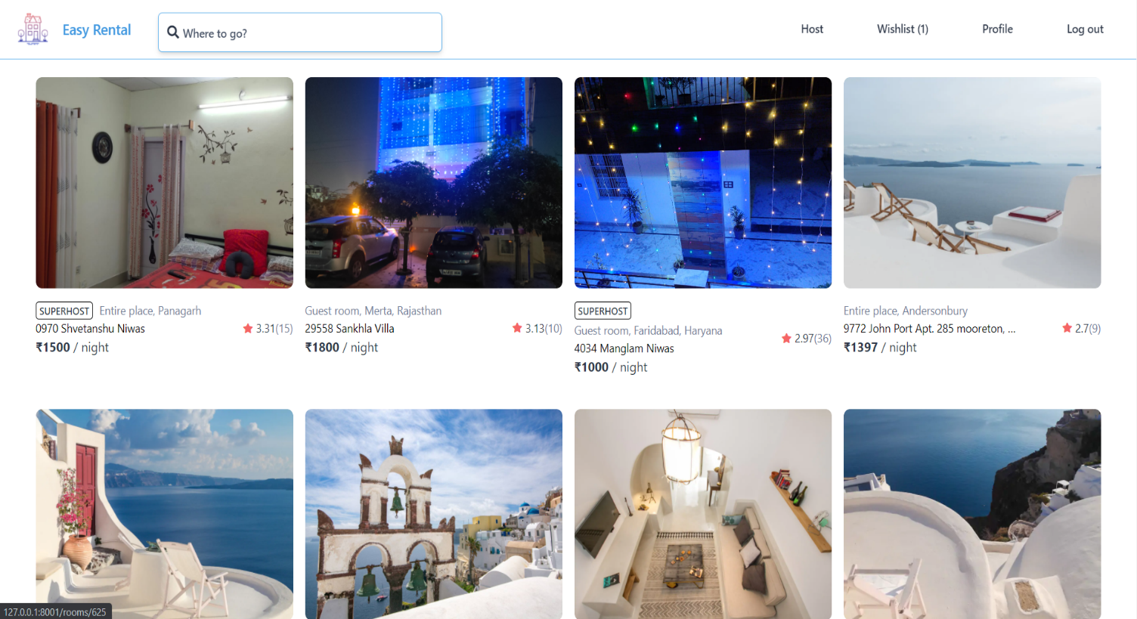

Figure 4: 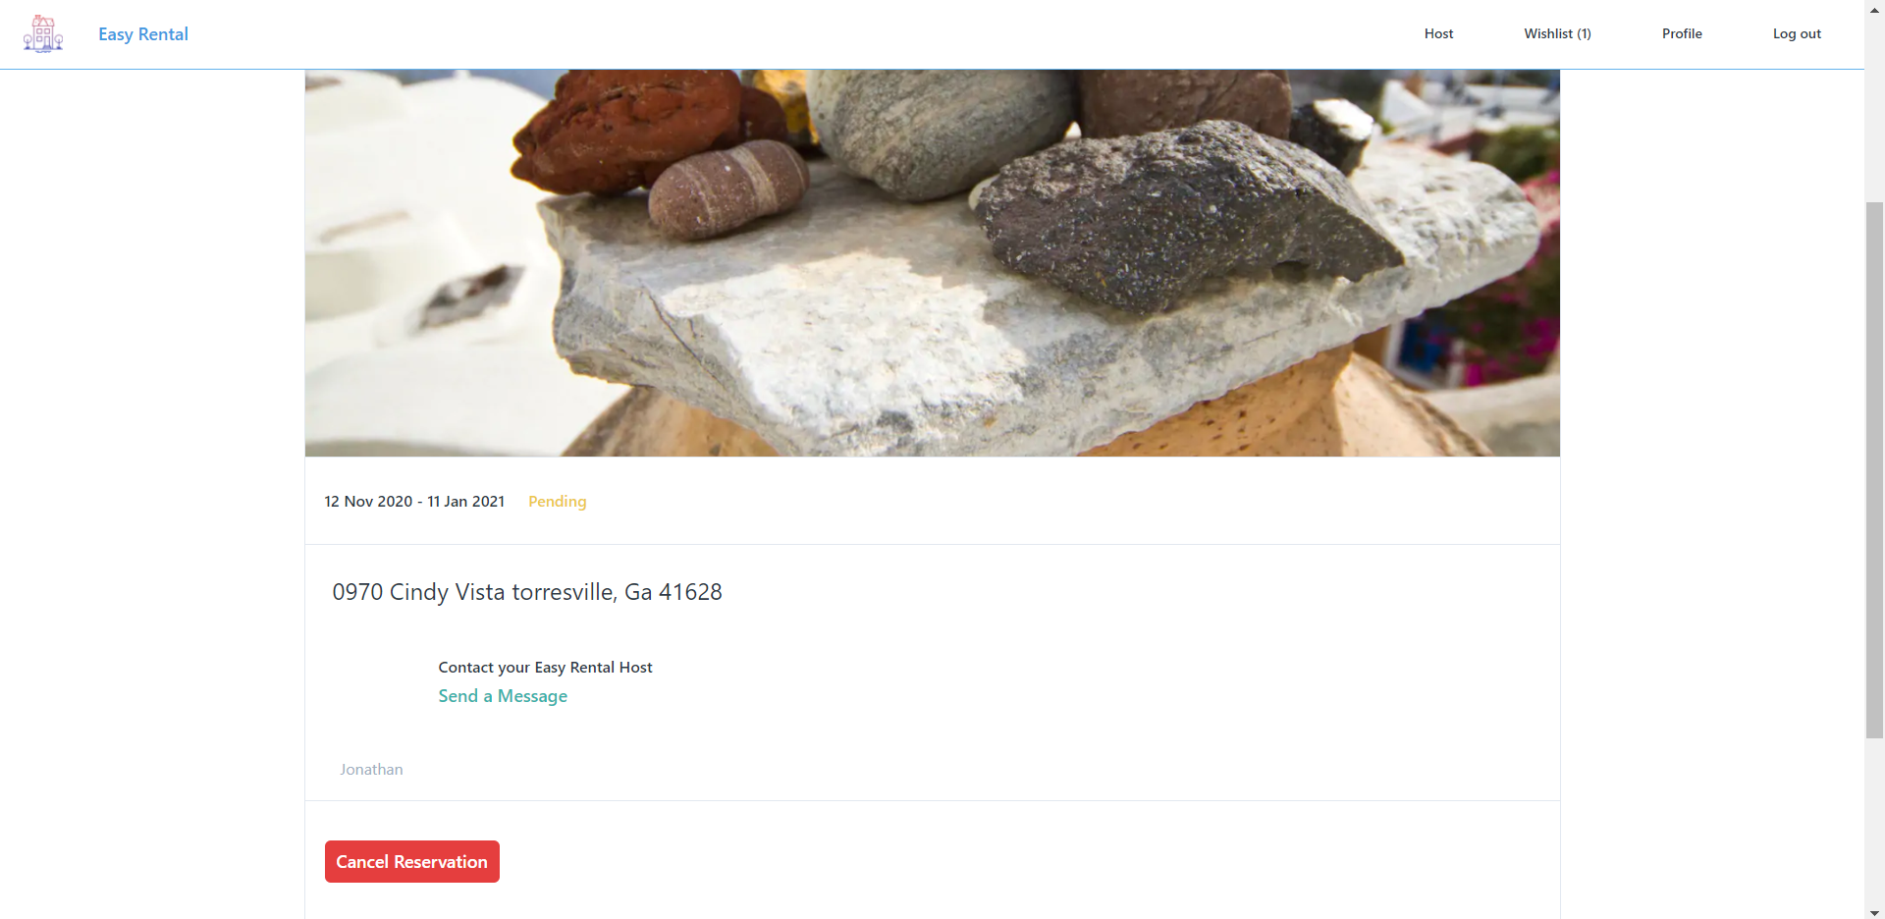 Figure 5: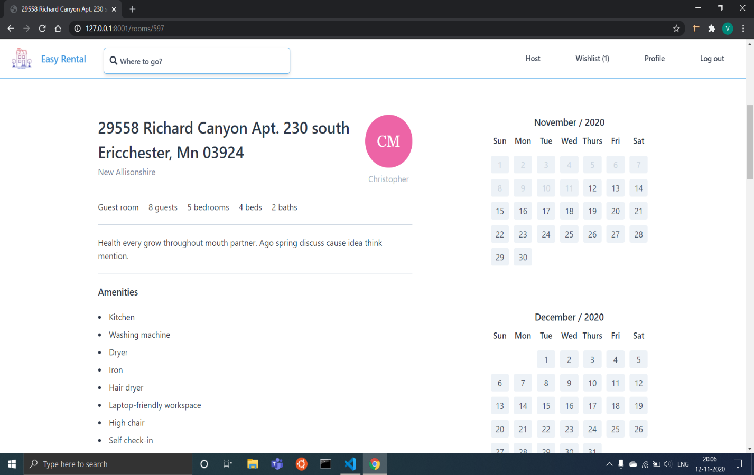

Figure 6: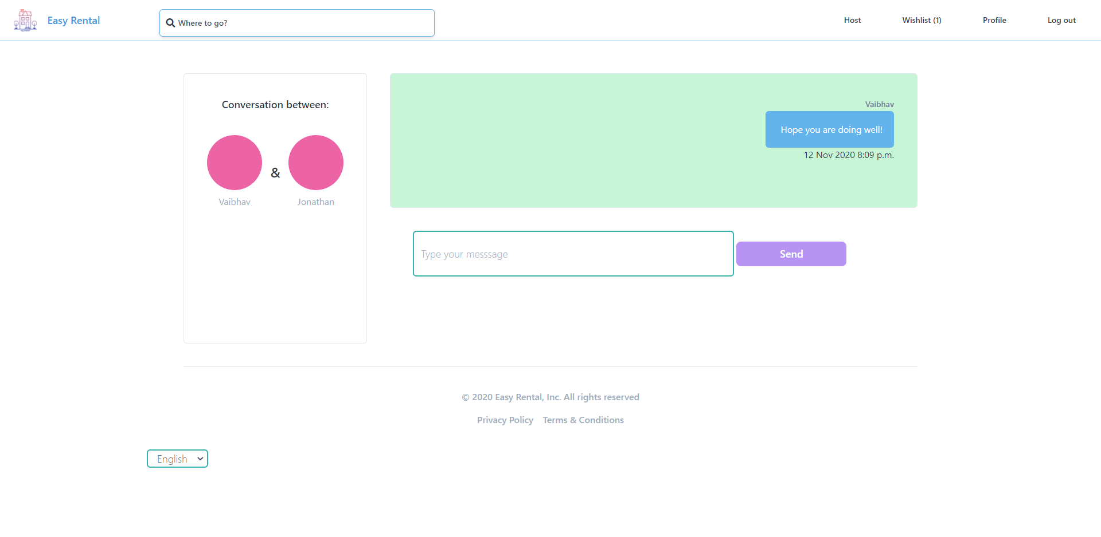

1. Production Code

**Figure 7:**

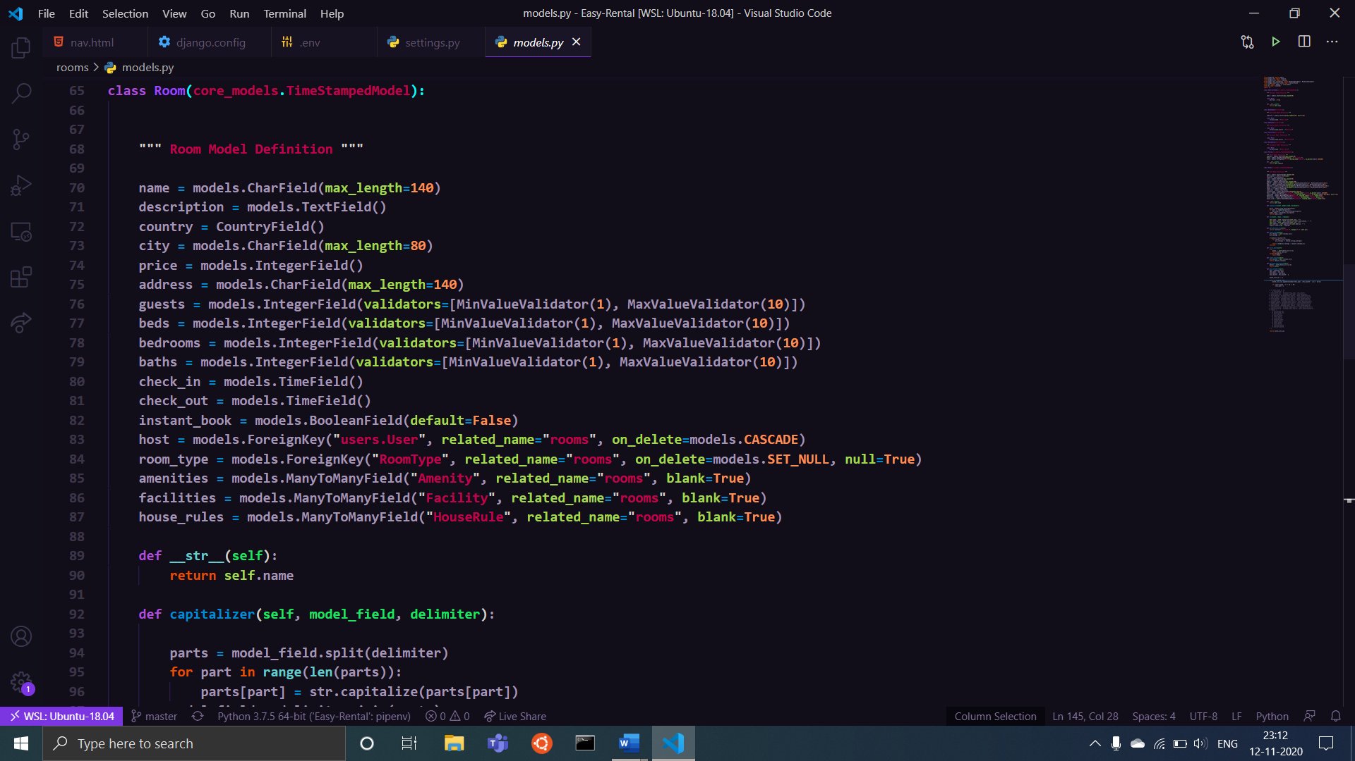

**Figure 8:**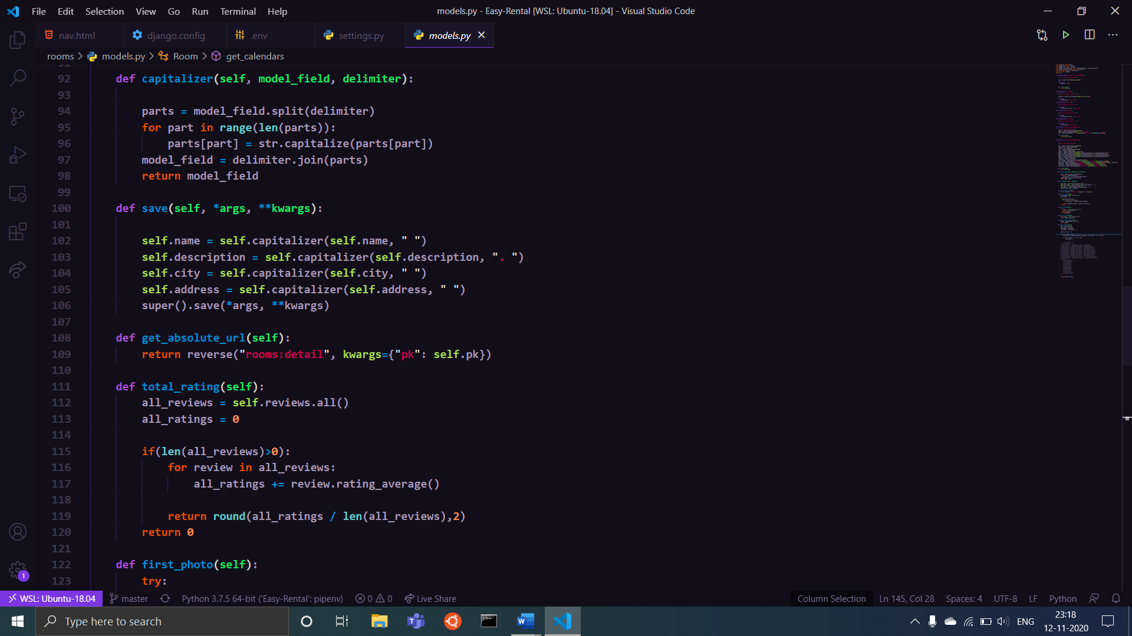

1. Project Closure

This section elucidates the overall lookup at the project and some of the future works that may enhance the solution.

* 1. Goals / Vision

Our original goals for this project were to eliminate the need for a broker between the owner and tenants and provide tenants with an option of home-style food service during their stay. Searching houses and make a valid booking should be smooth. Owners could list their property provide the description, rent, feature tags, and images. They could provide the location and manage all the rentals. Updating the property information such as location, services, photos, changing tags and description should be possible for tenants to make the right choices. The owner should have an option to accept/decline booking. This eliminates the need for a broker.

* 1. Delivered Solution

The delivered solution has tick-marked all the goals and objectives that we planned. But during the course of work, the goals were altered and our application could now provide room renting and booking functionality with a user-centric view in mind. The home-style food delivery service could not be implemented due to time constraints and excess of time spent in debugging and testing. Though, we plan to accomplish all our goals by the next semester.

* 1. Remaining Work

For further improving our course work, the following is the future work that we have planned to execute in the upcoming semester: -

* Geo-location on Google Maps will make it easy for the user to decide the location.
* The tenants, especially students and working professionals who have no prior cooking experience face a lot of difficulties to satisfy their hunger with nutritional food. Keeping that in mind, we would work on home-style food service.
* We also plan to collaborate with the industry, so the employees will have an option to stay in a building/apartment provided by their company. And they will be relieved of searching home in a new city.

REFERENCES

Several other blogs and documents have been studied while building up the proposal. Some of them have been cited below:

1. <https://www.coworkingresources.org/blog/coliving-spaces>

2. <https://www.investopedia.com/financial-edge/0611/understanding-real-estate-commissions-who-pays.aspx>